**CubeSat Sun Vector Determination Options**

**Overview**

Sun vector data is necessary for attitude determination algorithms such as TRIAD and solar pointing which maneuver satellite around for power generation and signal transmission. Purchasing a sun sensor to compute the sun vector can be costly and difficult due to tight mass and volume constraints required by CubeSat systems. Alternative solutions can be built or use existing components to generate the sun vector, including: photodiode sun sensors and coarse sun sensing using solar panels [1].

**Photodiode Sun Sensors**

Photodiode sun sensors use a box containing an array of photodiodes and with a slit on top. Light enters through the slit (similar to a camera pinhole model) and by using the geometry of the box and which photodiodes come into contact with light, the angle can be determined. The sensor has a wide 90-degree field-of-view. However, each sensor only covers one axis of determination, thus for three are required for operation. Requirements for the dimensions of the device are shown below.

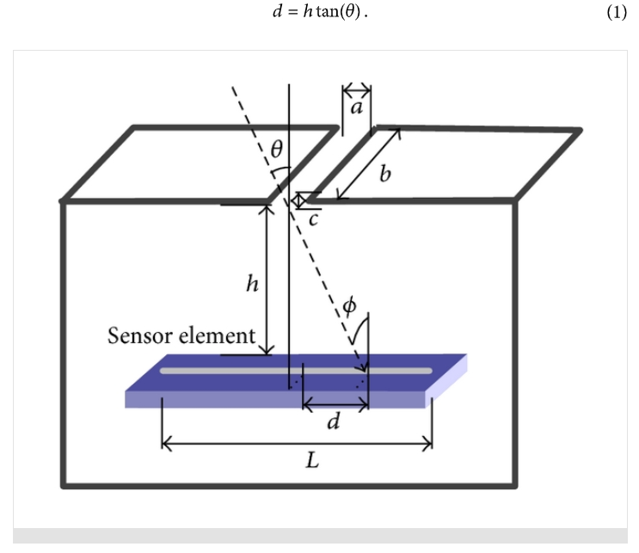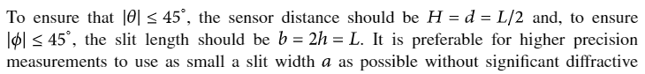

**Accuracy of Photodiode Sun Sensors**

For measurement purposes, the device was placed on a gimbal and rotated around a light source at various angles. The experiment does not account for additional sources of light (ex., Earth’s Albedo) and angles for other axes. A distribution of photodiode activation values is produced and the centroid is taken to account for *d*, distance across the array. Above formula used for angle determination.

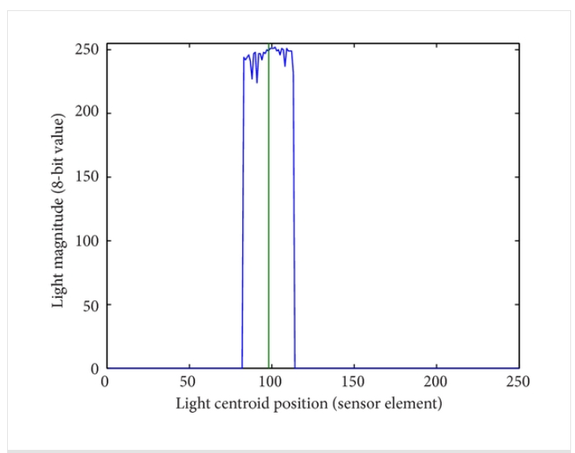, 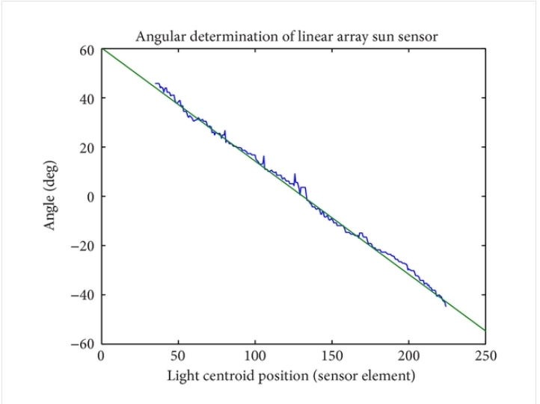

A plot of estimated versus actual solar angle is then shown; minimal variance of about 3-5 degrees.

**Coarse Sun Sensing using Solar Panels**

Two different types of setups can be used to determine sun vector using solar panels, however neither effectively accounts for additional sources of light (ex., Earth’s Albedo).

One method employs determining which quadrant of satellite’s body frame light is coming from. The amount of current per each solar panel (in positive x, positive y, and negative y directions) is compared. Depending on an inequality that determines which panel generates the highest current, a different formula is used to determine the angle per that axis.

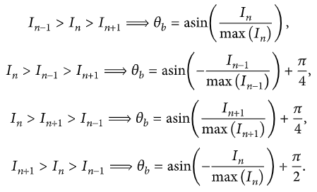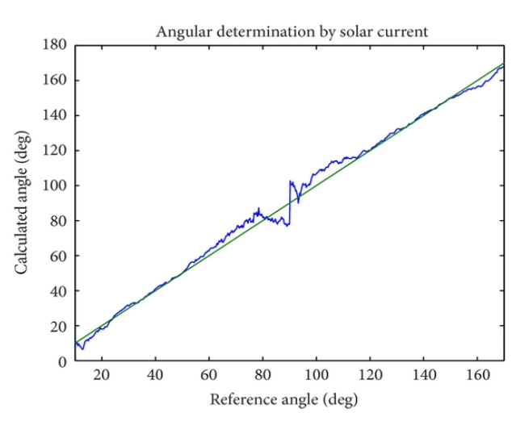

According to results generated from an experiment which rotated the device using a gimble, the variance in angular determination versus true angle is higher, especially near the range 90 – 120 degrees. This is due to the mapping equations used to determine sun angles relative to body frame. Overall this solar panel configuration generates a variance of 7 degrees.

Another method uses a similar approach, however simplifies analysis by comparing generated current to maximum current output per each solar panel. Then to account for which faces the panels are located on, it uses a variable *n* that indicates whether panel faces positive or negative axis direction.

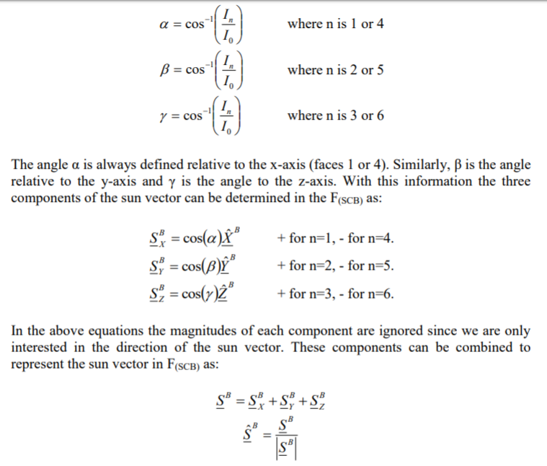

The sun vector relative to the body frame is computed and can be fed into Simulink model for testing purposes.

**References**

1. Post, A.M., Lee, R. A Low-Cost Photodiode Sun Sensor for CubeSat and Planetary Microrover. December 17, 2013. <https://www.hindawi.com/journals/ijae/2013/549080/#EEq6>.